**2.5 The projective geometry of 1D**

: Homogeneous coordinates of point x on line  : ideal point of a line

Projective transformation of a line   🡪 3 DOF

🡪 A projective transformation of a line may be determined from three corresponding points

선의 사영 변환은 3개의 대응점으로부터 결정될 수 있다.

**The cross ratio**





The cross ratio is invariant under projective transformation of the line in



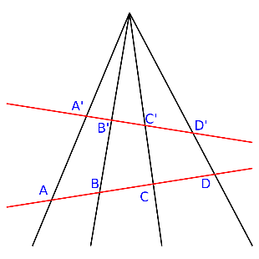

* Properties:   
  - Defines coordinates along a 1D projective line  
  - Independent of the homogeneous representation of x  
  - Valid for ideal points  
  - Invariant under homographies (Projective transformation)

Projective transformation between lines with equivalent cross ratio

1D projective transformation is induced on any line in the plane

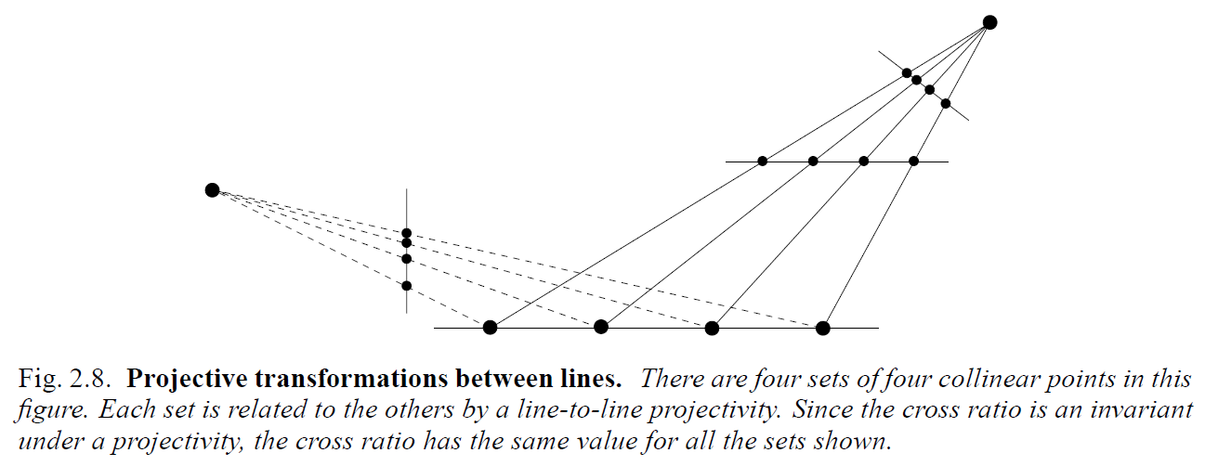

**Concurrent lines; dual to collinear points on a line** 공점선 : 공통인 한 점을 지나는 직선들

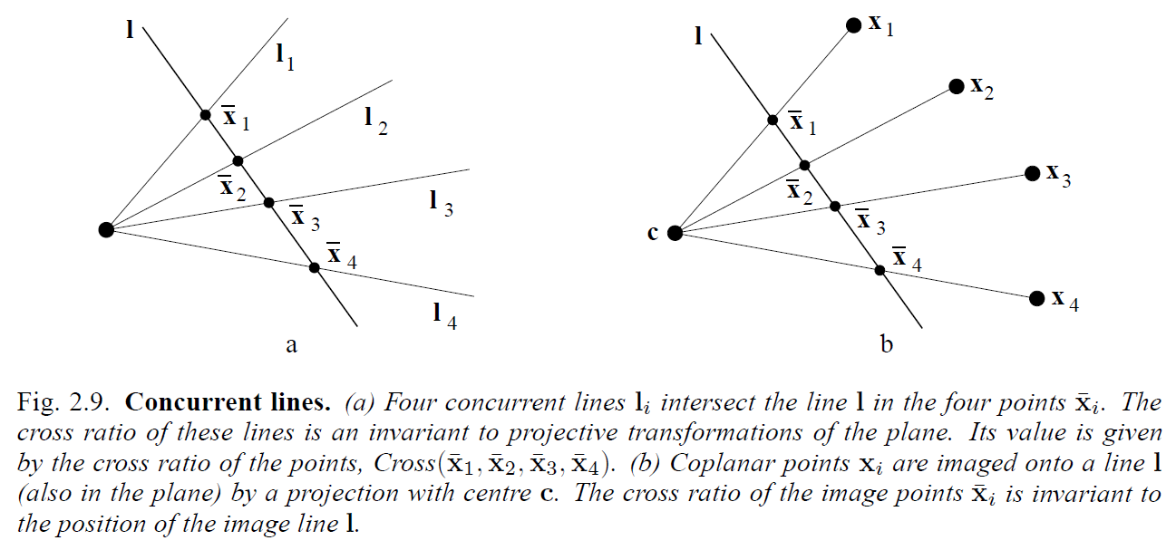

|  |  |  |
| --- | --- | --- |
| Screen%20Shot%202015-09-21%20at%209.57.27%20PM.png |  | Screen%20Shot%202015-09-21%20at%209.59.47%20PM.png |
|  |  |  |

Perspectivity property : concurrent

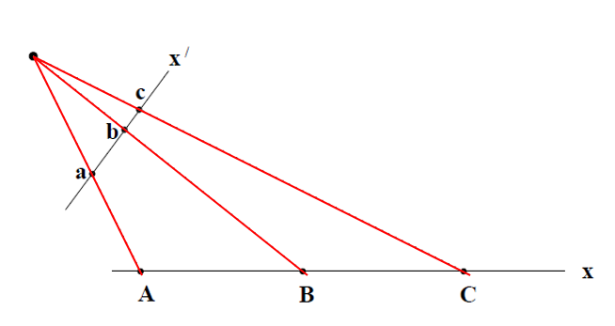

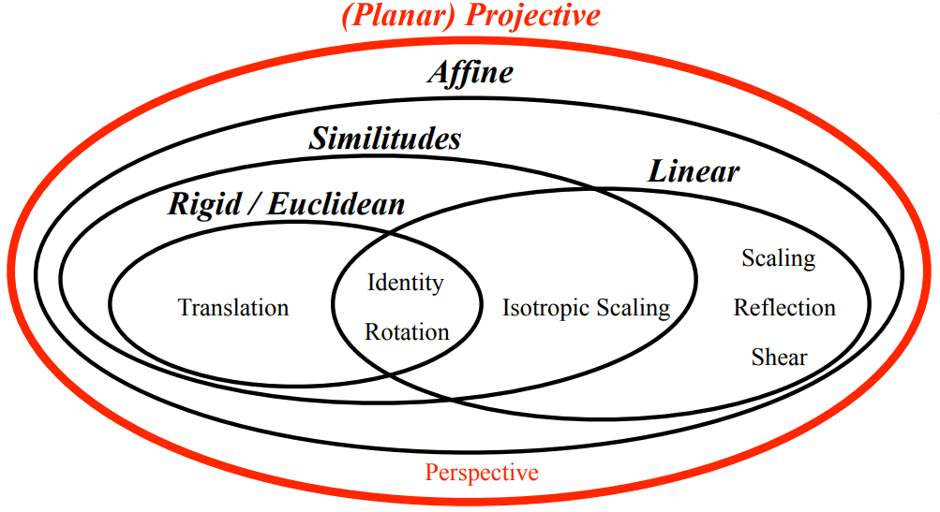

**2.7 Recovery of affine and metric properties from images**

|  |  |
| --- | --- |
| Review) **Geometry properties [1]**   * Affine properties (line at infinity) distorted by Hp * Parallelism * Parallel length ratios * Metric properties (circular points) distorted by Ha * Angles * Length ratios | → Recover the original shape  Hp : Projective transform  Ha : Affine transform |

Projective transform된 영상에서 왜곡된 affine properties와 metric properties를 복원하면 왜곡되기 전 원영상의 모양을 복원할 수 있다.

** 이해 안 되는 부분

The projective distortion in the perspective image of a plane is removed by specifying 4 points (8 DOF)

However, only 4 DOF (not 8) is required to specified in order to determine metric properties

These 4 DOF are given physical substance by associating them with geometric objects:

* The line at infinity  (2 DOF) and the two circular points (2 DOF) on 

**2.7.1 The line at infinity**

line at infinity: ideal point로 연결된 직선

* Euclidean Plane : 무한이 먼 곳 🡪 표현 x, 평행선(affine properties) 보존
* Projective transformation : ideal point, line at infinity 🡪 실제 점, 직선으로 매핑 🡺 평행성 잃음  
  🡺 affine properties 왜곡

Under a projective transformation ideal points may be mapped to finite points and consequently  is mapped to a finite line. If the transformation is an affinity, then  is not mapped to a finite line, but remais at infinity.

For an affine transformation line at infinity maps onto line at infinity



**The line at infinity  is a fixed line under the projective transformation H if and only if H is an affinity (not projectivivity)**

Note :  is not fixed pointwise (not the same point)

A point on line at infinity is mapped to another point on the line at infinity, not necessarily the same point

Euclidean Plane에서 ideal point가 무한에서 먼 곳에서 만나기 때문에 표현 불가능  
similarity, affine 변환에도 ideal point 이동할 뿐 그 canonical position에 존재하기 때문에 line at infinity 또한 canonical position에 존재 🡺 평행선은 여전히 평행하여 affine properties 보존

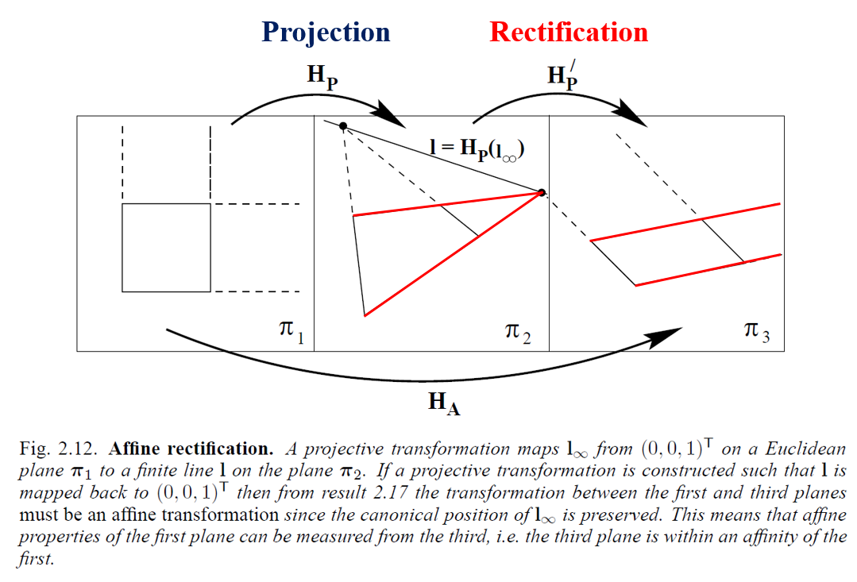

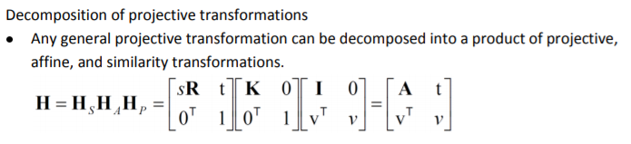

Projection

Mapping of ideal point Mapping of line at infinity

 

**2.7.2 Recovery of affine properties from images**

Example 2.18 Affine rectification

Moving to canonical position



평행한 직선에 다시 평행성을 복원하여 affine properties 복원 🡪 실직선으로 매핑된 를 (0,0,1)t로 이동 🡺 의 정보로 만들어진  곱하기

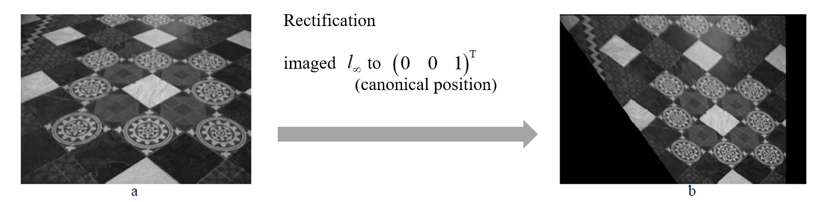

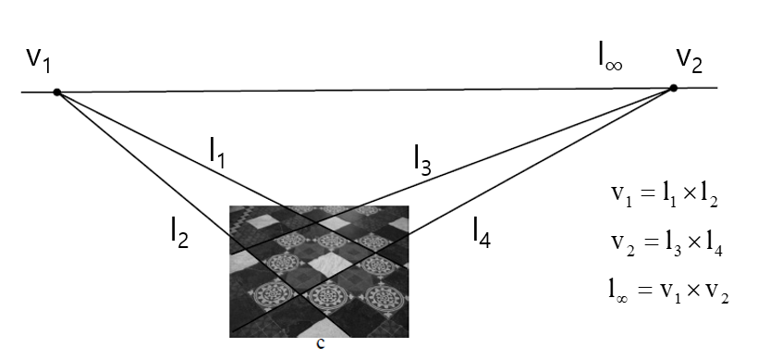Metric properties(angles, length ratios)는 복원되지 않아 원본과 같지 않다.

평행한 직선 2개 외적

🡪 vanishing point

2개의 vanishing point 외적

🡪 vanishing line

vanishing line 🡪 Hp’

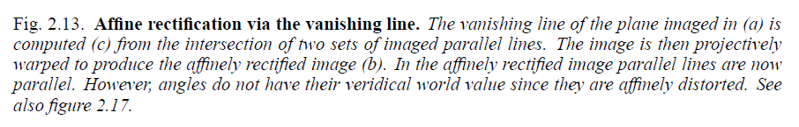

World plane

* Ideal point 🡪 vanishing point
* Line at infinity 🡪 vanishin line

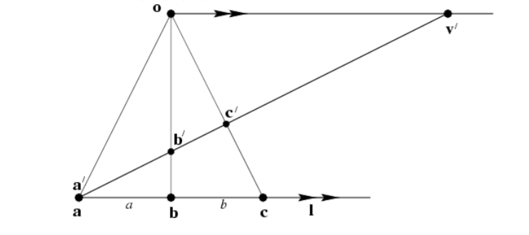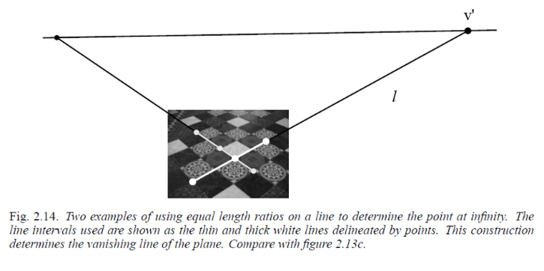Example 2.19 Computing a vanishing point from a length ratio – using invariant cross ratio



Example 2.20 Geometric construction of vanishing points from a length ratio

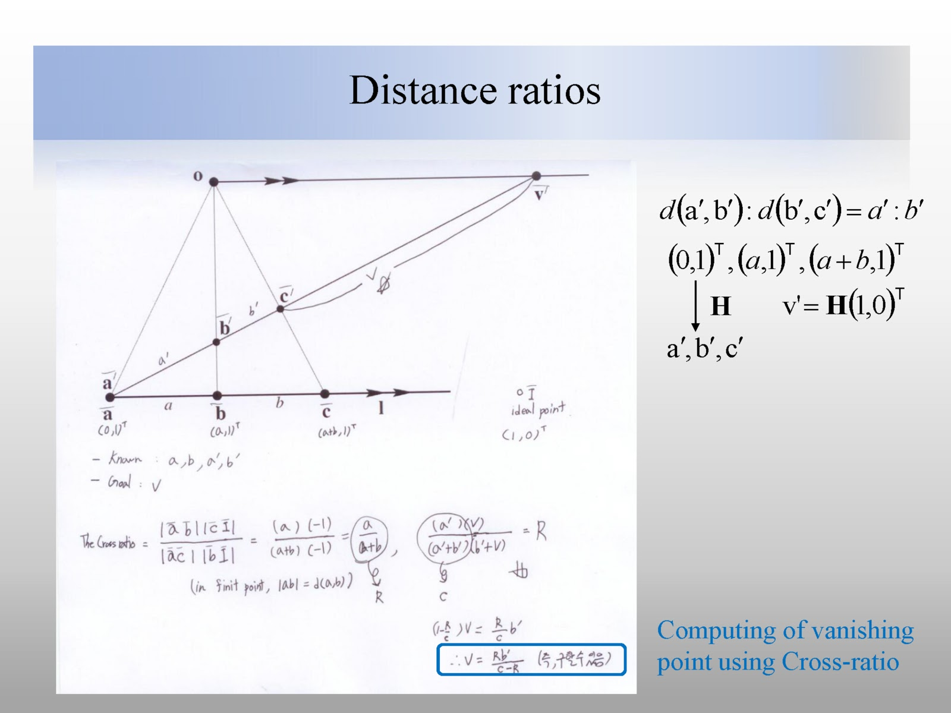

**2.7.3 The circular points and their dual – Metric rectification**

Two points on ** 🡪** Every circle intersets  at circular points (absolute points)

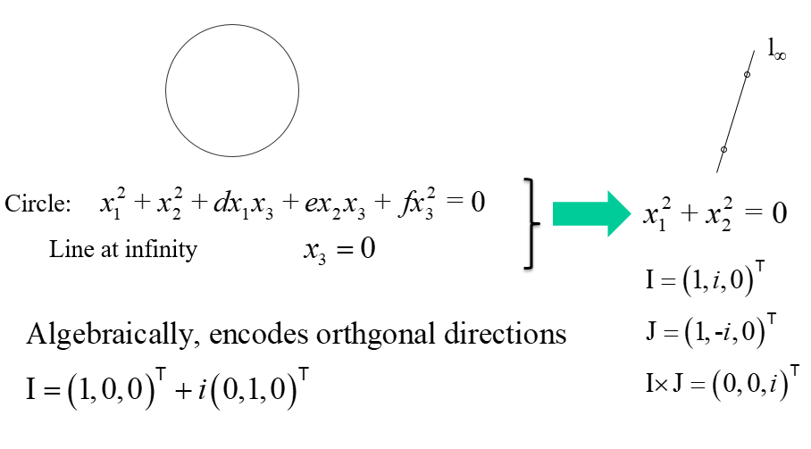

circular points (absolute points)

* I, J : canonical coordinates를 사용하며 a pair of complex conjugate ideal points
* similarity transform에서 불변하는 점



* **The circular points, I, J are fixed points under the projective transformation H iff H is a similarity.**similarity transform에 불변함

Identifying circular points allows recovery of similarity properties i.e. angles, ratios of lengths

**The conic dual to the circular points**



* **The dual conic  is fixed under the projective transformation H iff H is a similarity**.  
  두 circular points로 표현되는 degenerated dual conic은 similarity transform에 불변  
  line at infinity는 the dual cunic의 null vector (circular point가 line at infinity 위의 점임을 생각)

reminder) degenerated line conic  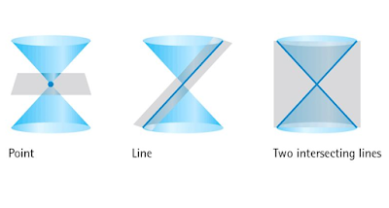

Note)  has 4 DOF (3x3 homogeneous; symmetric, determinant is zero)  
 is the null vector

**2.7.4 Angles on the projective plane**

< Angles >



Euclidean Geometry :  not invariant under projective transformation

Projective Geometry :  invariant under projective transformation

* **Once** ** is identified in the projective plane, the Euclidean angles may be measured by (2.22)**
* **Lines l and m are orthogonal if**  **(orthogonal)**

< Length ratios >

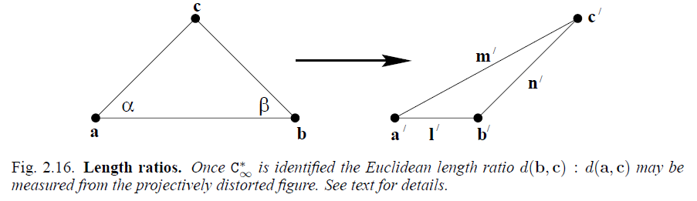



affine transform 🡪 angles 변형됨

 이므로 분자가 0이면 두 직선 직교(orthogonal) 🡪 transformed dual conic 구함  
🡺 transformed conic dual to circular points (on the projective plane)를 identify 해서 (2.22) 식에 적용하여 원래 각도를 계산할 수 있다. (각도 복원 ~ 선분의 길이비 복원)

**2.7.5 Recovery of metric properties from images**

**Metric rectification using **

 

* Once the conic  is identified on the projective plane then projective distortion may be rectified up to a similarity K : 2x2 v : 2x1

similarity transform 불변, projective(v)와 affine(K) 변환 요소만 남는다.

Rectifying transformation from SVD



SVD decompose to get U

* Recovering up to similarity from Projective

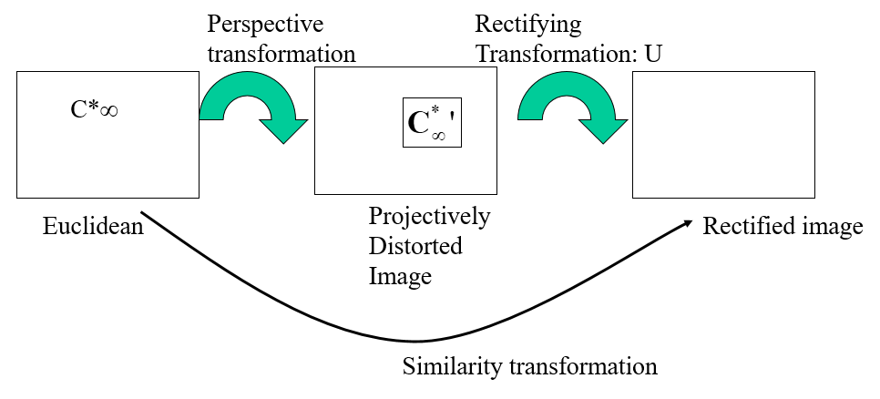

* Recovering up to similarity from Affine

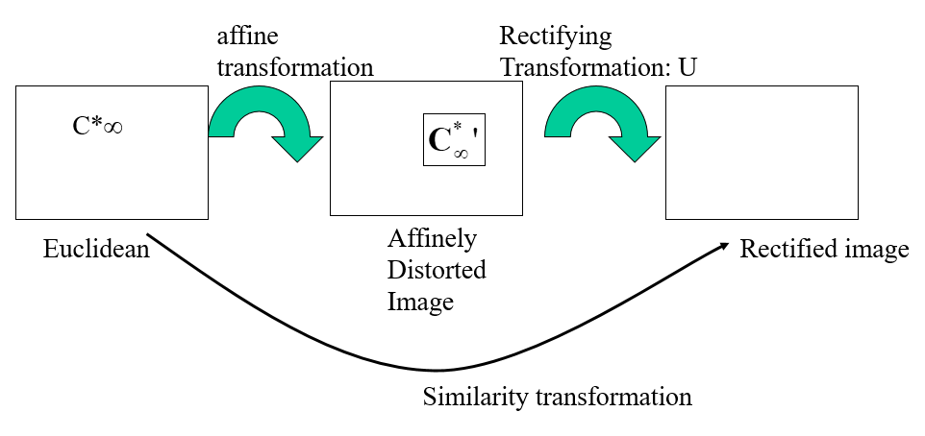

**Metric rectification I : Affine rectiffication**

if  l, m are othogonal

  

affine rectification 경우 Hp 변환이 제거된 것이므로 v = 0으로 K만 고려

K 2x2 🡪 3DOF : 직교하는 직선 2개를 사용해서 transformed dual conic  구할 수 있다.

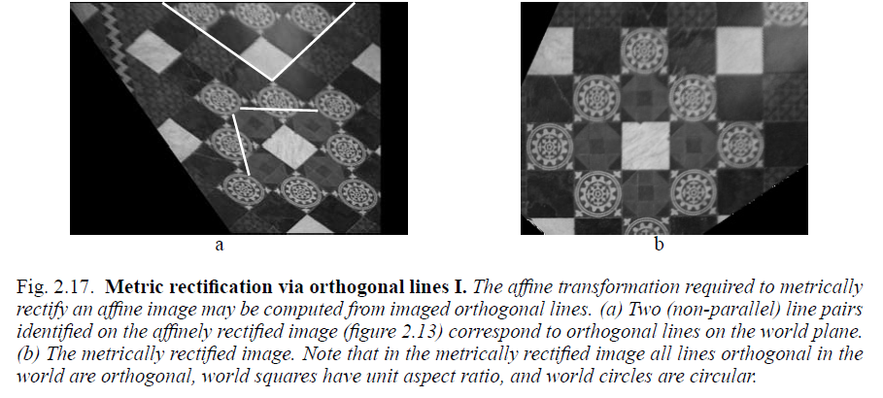

**Metric rectification II : Projective rectification (not affine rectification)**





5 DOF : 직교하는 직선 5개를 이용하여 사용해서 transformed dual conic  구할 수 있다.

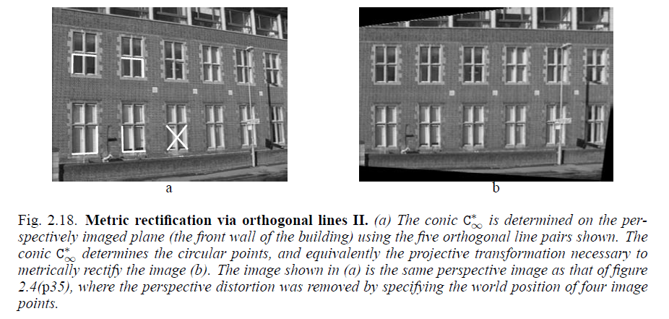

**Stratification**

1. projective
2. affine distortions were removed

transformed dual conic  를 구한다는 것은 transform을 측정한 것과 같고 원 영상에서의 각도와 길이 비율을 구하여 metric properties를 복원한 것이다.

conic C



degenerate conic  

gives angle  between transformed lines l’, m; 

Metric rectification

* Transformed has 4 DOF
* convert  to   matrix
* find , then find   from it...

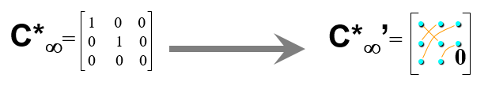

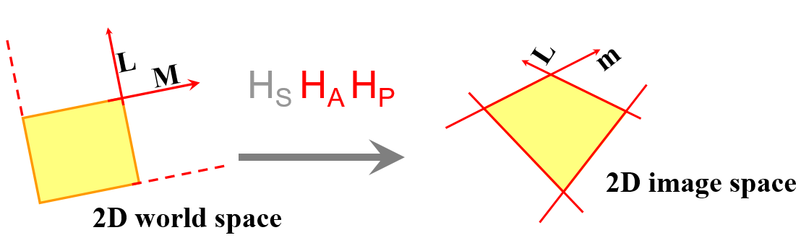



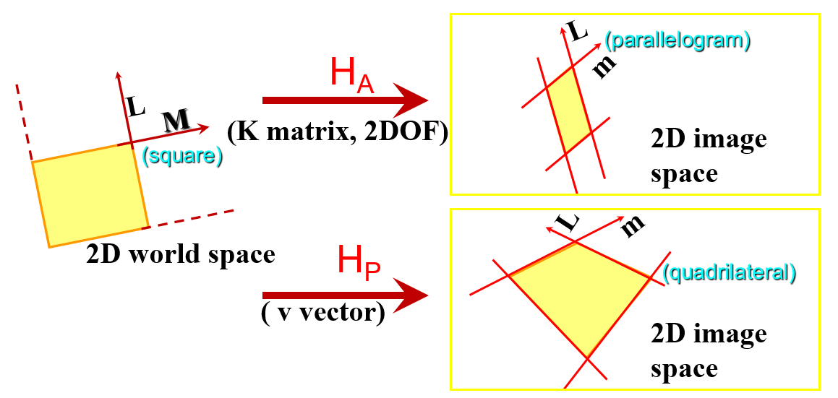

world space transformed 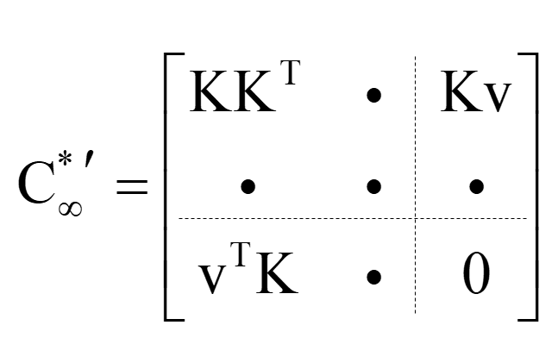

* we know 2 world space line l, m ; 
* also true for transformed l, m,  ; 
* K 2x2 symmetric (affine part : 2DOF)
* v 2x1 vector (projective part : 2DOF)

metric rectification

* method 1 : v=0, solve for K

 

 

solve for s by SVD : find input null space (Ax = 0)

* method 2 : Rearrange, solve for full  then get  using SVD



choose 5  line pairs  🡺 





stack for all 5 line pairs



solve for a,b,c,d,e,f, with SVD (null space; Ax=0)

Extract  from  using SVD

SVD 설명 [2] [3]

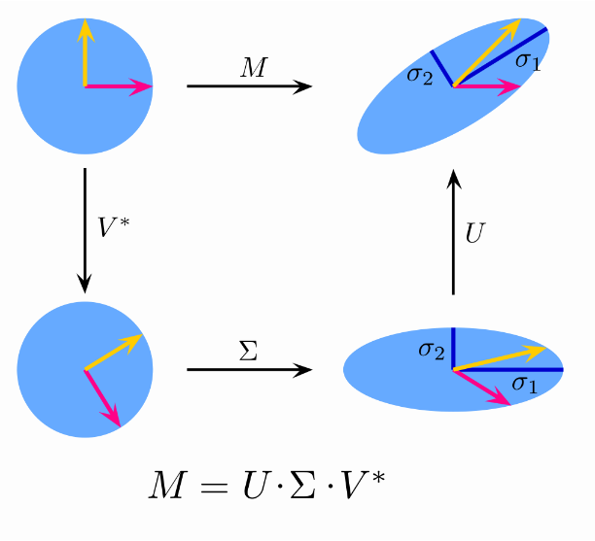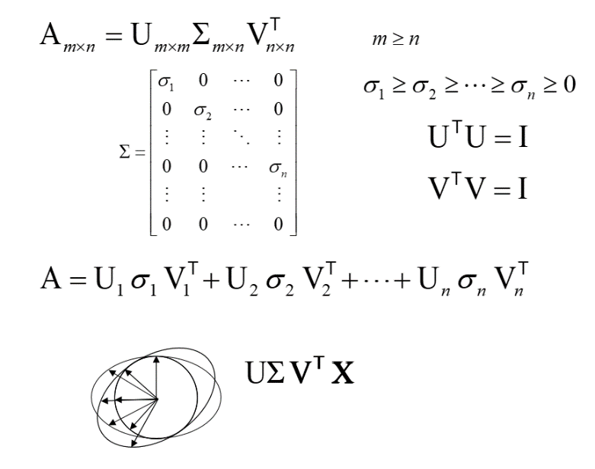선형변형 후에도 크기는 변하지만 여전히 직교하는 벡터의 집합 – 여러 layer로 쪼갤 수 있다.

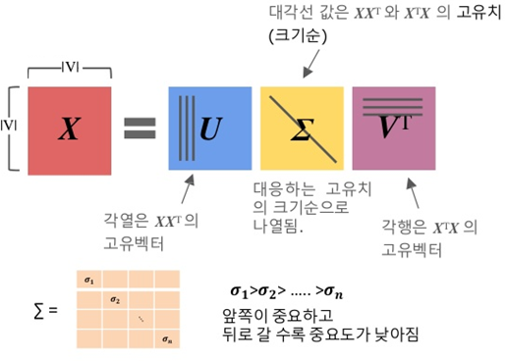

1. http://scribbleonit.blogspot.com/2013/01/multiple-view-geometry-3.html
2. https://wikidocs.net/25820
3. https://rfriend.tistory.com/185